**Quantum computing is a beautiful fusion of quantum physics and computer science, incorporating some of the most stunning ideas from twentieth-century physics into an entirely new way of thinking about computation.**

**Reference**: Quantum Computing for Everyone

- [Chris Bernhardt](https://mitpress.mit.edu/contributors/chris-bernhardt)

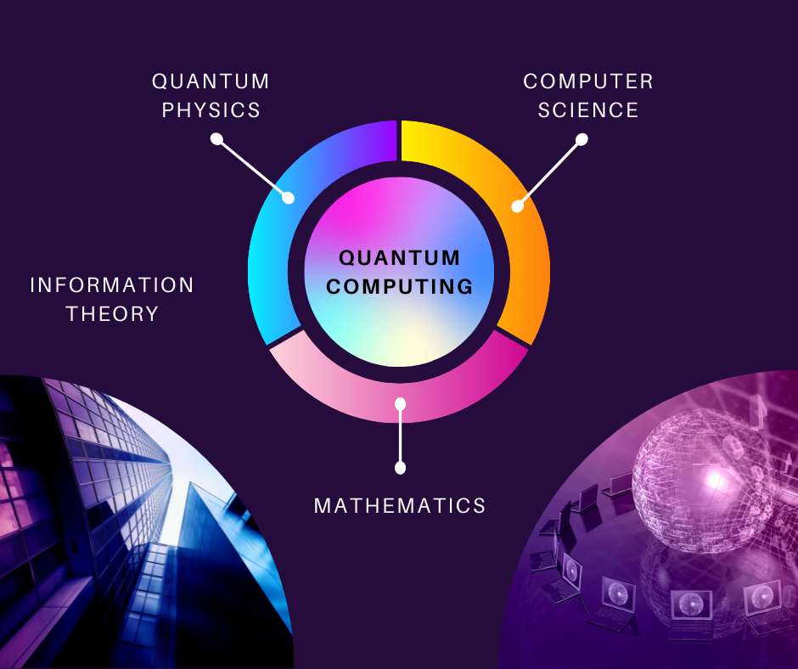

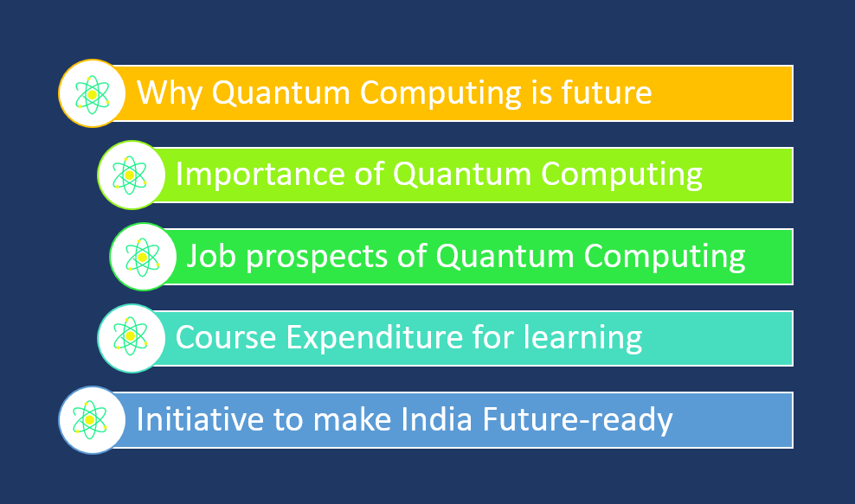**INDEX**



Why Quantum Computing is Future

According to the Report titled “Quantum Technology Market by Computing, Communications, Imaging, Security, Sensing, Modeling and Simulation 2022 – 2027”, We can observe global and regional forecasts as well as the outlook for quantum technology's impact on embedded hardware, software, applications, and services from 2022 to 2027.

* Overall global quantum technology market will reach $42.4 billion by 2027
* Quantum computing will lead the market at $16.1 billion by 2027 and 39.4% CAGR
* North America will be the biggest regional market for quantum technologies overall
* China will lead the APAC quantum technology market at $5.41 billion by 2027 with a 38.5% CAGR
* Germany will lead the European quantum technology market at $3.6 billion by 2027 with a 33.1% CAGR
* The global quantum dots market will reach $13.25 billion by 2027, growing a 25.1% CAGR and led by displays
* The quantum sensing market will reach $989 million globally by 2027, nearly twice the size of the quantum imaging market
* The quantum magnetometer market will reach $925 million globally by 2027, led by superconducting quantum interference devices

Quantum Computing is a trending technology and has been widely adopted by various countries. The global quantum effort leading to research and innovation in quantum science and technology is continually rising with current worldwide investments reaching almost $30 billion.

**Overview of public funding in quantum technologies**

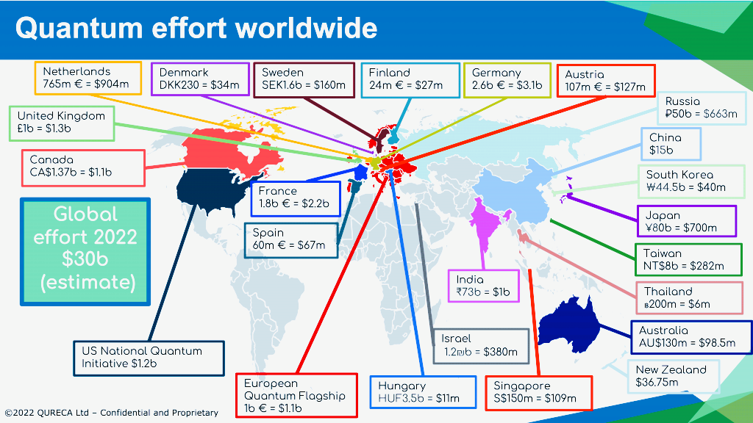

**Insights of Country-wise Details**

**India:**

* In 2020, The Indian government has introduced an NM-QTA (National Mission on Quantum Technologies and Applications) with a total budget of INR 8000 crores (approximately $1 billion) over five years.
* Finance Minister Nirmala Sitharaman stated that a lot of commercial applications are expected to emerge from theoretical constructs developing in quantum technology.
* Indian Institute of Science has a dedicated research area for quantum technology.
* The Initiative on Quantum Technology explores many areas such as superconducting qubit devices, single-photon sources and detectors for quantum communications, integrated photonic quantum networks, and quantum sensors.

**China:**

* China is believed to be one of the leading nations in quantum information science, as the country began investing in quantum research and development very early on, by the end of the 90s.
* Over the past two decades, quantum information science has received significant recognition in China, as the First Prize of National Natural Science of China in 2013 and 2015 has been awarded to this field.
* By 2030, the country aimed to expand its national quantum communications infrastructure, by developing a general quantum computer prototype and constructing a practical quantum simulator.

Canada:

* Canada is considered one of the world’s leading nations in quantum research. It has invested more than $1 billion in quantum research over the past decade.
* It has a growing impact on the private sector, outstanding research expertise, and extensive government commitment to innovation.
* Canada is in a very strong position to drive quantum technology development.
* As of April 2021, the Canadian Government announced a further $360 million investment to launch a National Quantum Strategy.
* Quantum Algorithms Institute will receive $2.2 million from the Canadian Government to accelerate innovation and commercialization in quantum technologies.

Japan:

* Its total investment for quantum information science and technology is around ¥30 billion.
* The main funding agencies have been the Japan Science and Technology Agency, the National Institute of Information and Communications Technology, the Japan Society for the Promotion of Science, and the Cabinet Office of the Government of Japan.
* For example, the Japanese Government launched the Q-LEAP initiative in 2018 to invest in R&D projects in three fields of quantum technology:

1. Quantum simulation and computation,
2. Quantum sensing,
3. Ultrashort pulse lasers.

* New Japanese initiatives have recently been launched in 2018 to advance quantum information science and technology to the next phase.
* The Moonshot Project is expected to invest around ¥15-20 billion to create a fault-tolerant universal quantum computer by 2050.

France

* France has been investing 60 million € in quantum technologies every year.
* In 2020, plan they announced the strategic recommendations.

1. Deploy cutting-edge quantum computing infrastructure for research and industry.
2. Launch an ambitious technological development program.
3. Implement a program for supporting the development of applications.
4. Create an effective environment for innovation.
5. Deliver a tailored economic security strategy.
6. Establish effective governance.

Many such initiatives can be seen in various fields and sectors throughout the world. Still, if anyone thinks Quantum is future technology, then they are wrong.



This year IBM plans to release a 433-qubit processor called Osprey. Osprey features a smaller chip that ensures more logical qubits that don’t sacrifice performance.

In 2023, IBM plans to release a 1,121-qubit processor called Condor to succeed Osprey. By the time Condor is released, IBM believes they will be close to a “quantum advantage”, the point at which quantum computers outperform classical computers.

Importance of Quantum Computing

One classical machine learning approach optimized a portfolio in 33 hours; hybrid quantum annealing produced similar results in three minutes.

* **Konstantinos Karagiannis**

(Associate Director with Quantum Computing Services at Protiviti)

Quantum will soon reach a tipping point when quantum revolutionizes information security, fraud detection, logistics, and other optimization- and simulation-friendly activities.

Sooner or later organizations will struggle to find and hire the quantum talent they need. The first wave is already underway, organizational leaders must understand what quantum computing is, which activities it is best suited for right now, and the challenges and enablers that must be addressed to facilitate its use and advancement in this area.

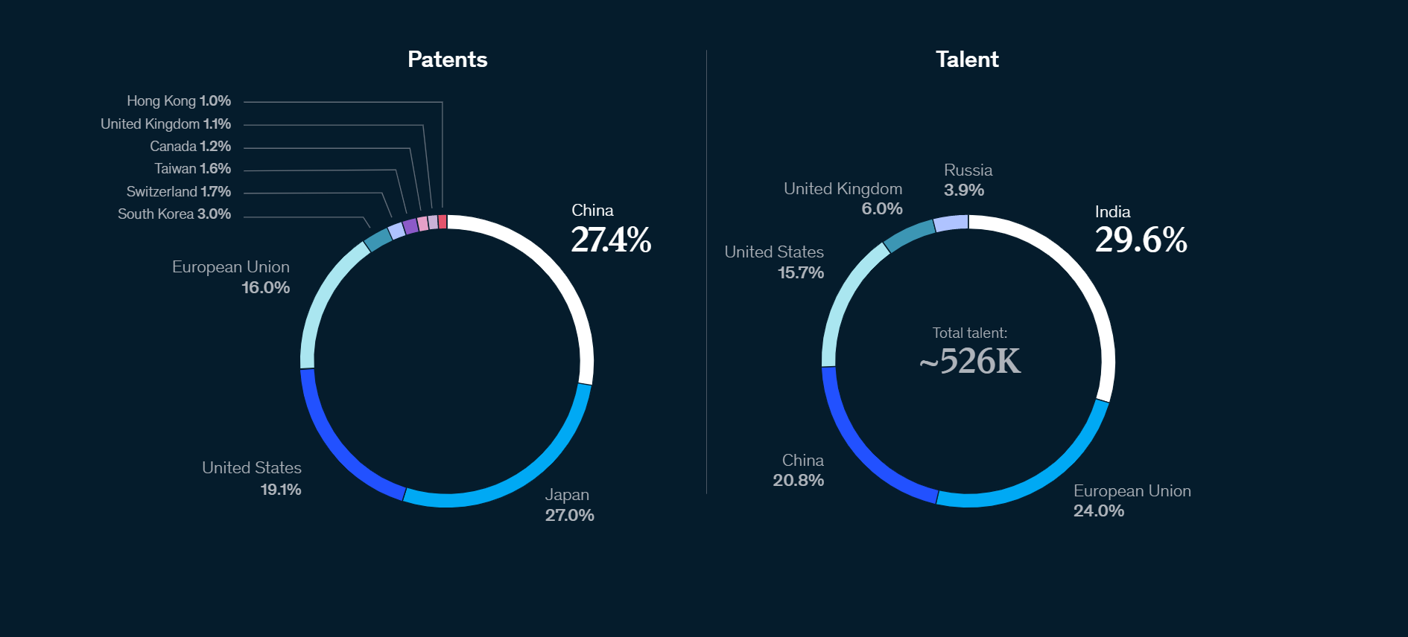

From McKinsey “China is leading in quantum technology patent activity, and India has the largest pool of relevant talent”.

**Market Map**

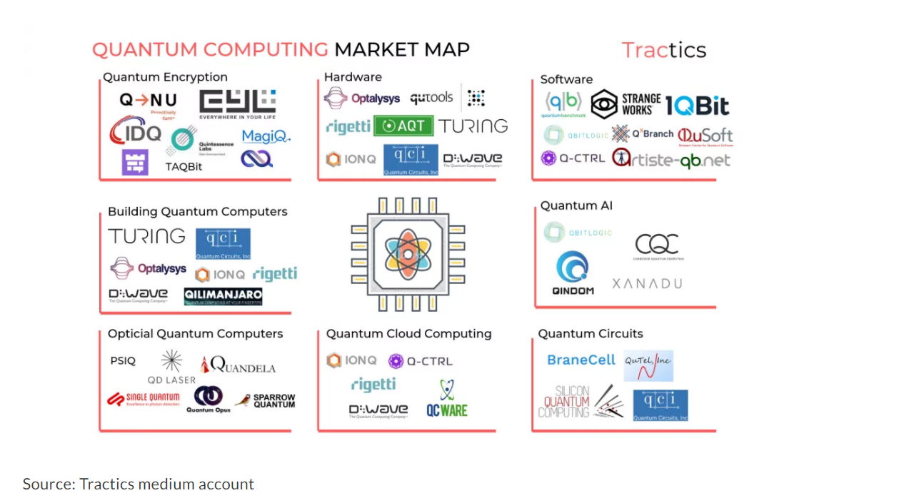

**Use Cases of Quantum**

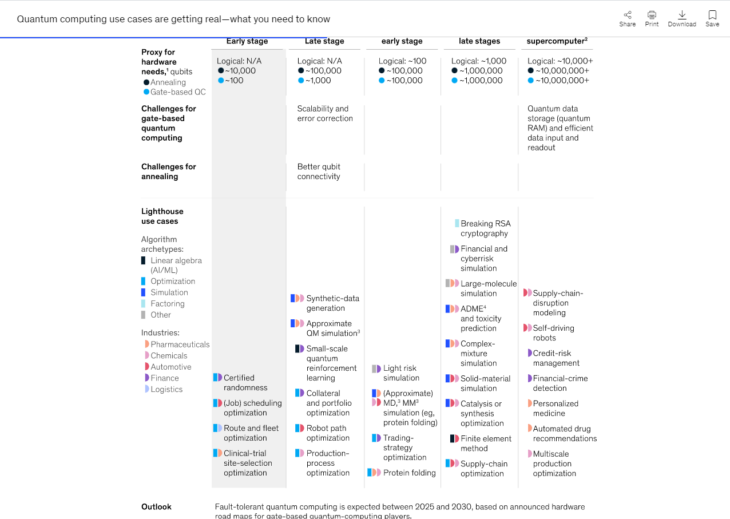

Image source and Credit: **McKinsey**

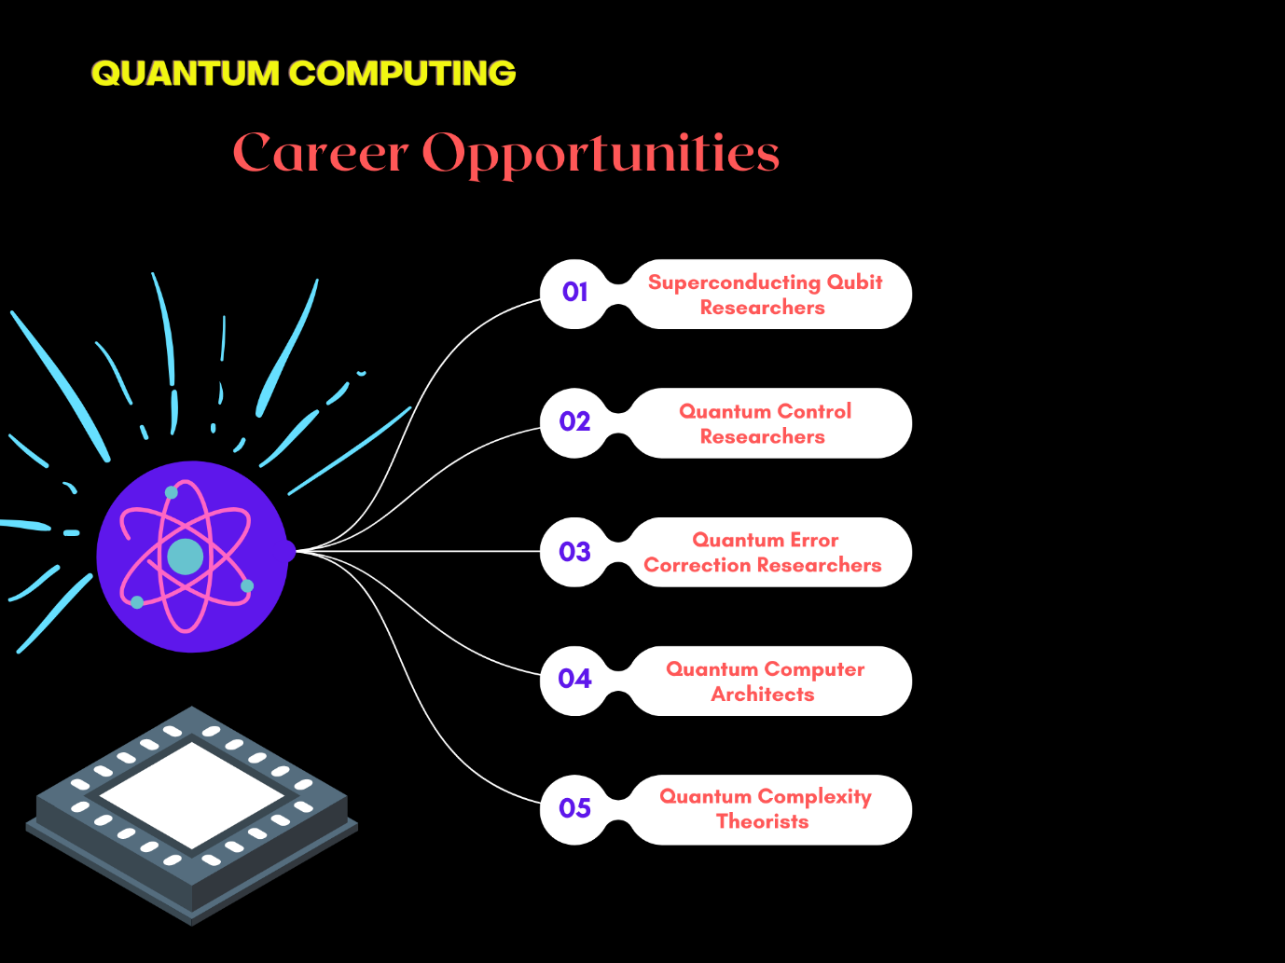

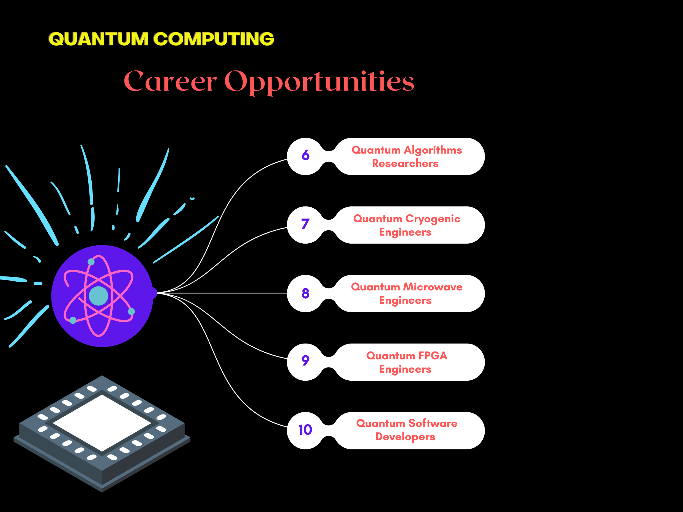

Small specimen of Job Roles

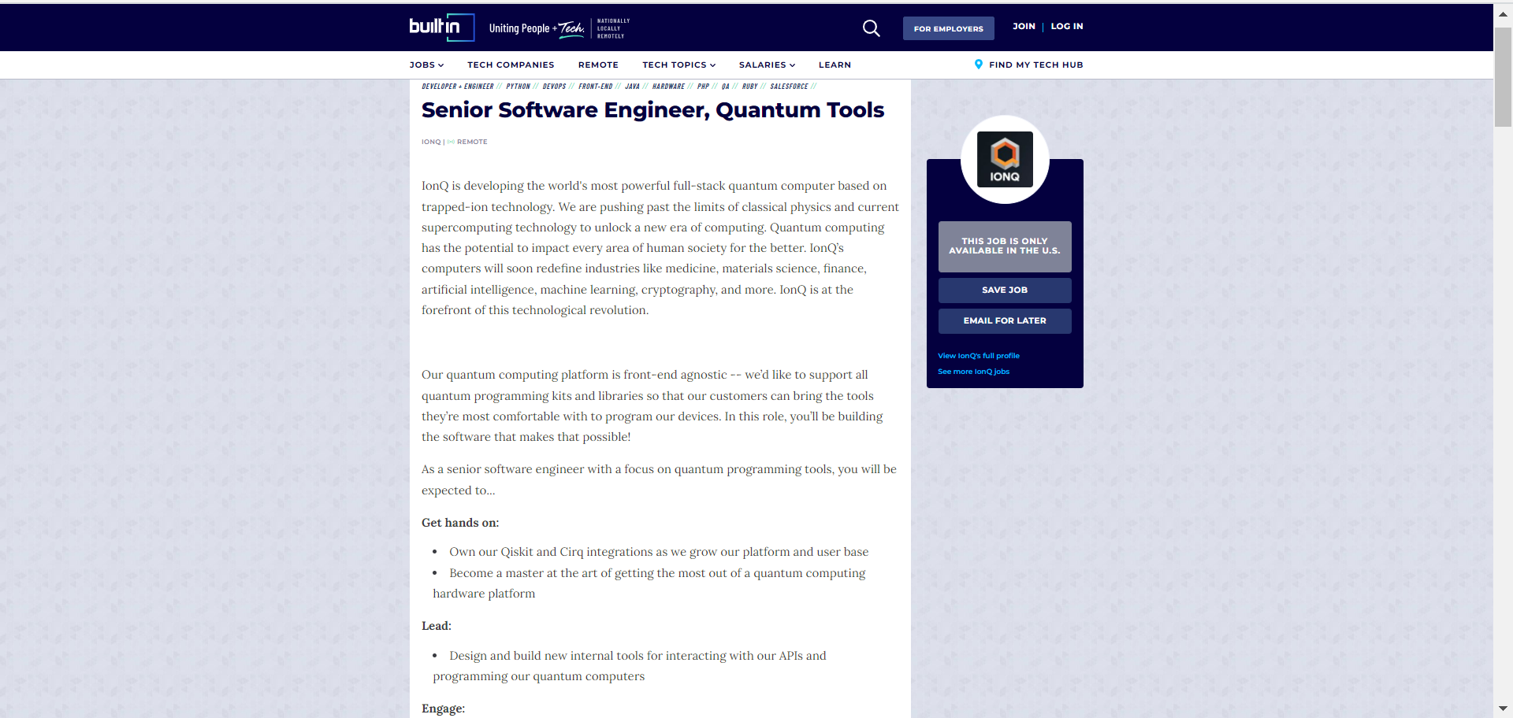

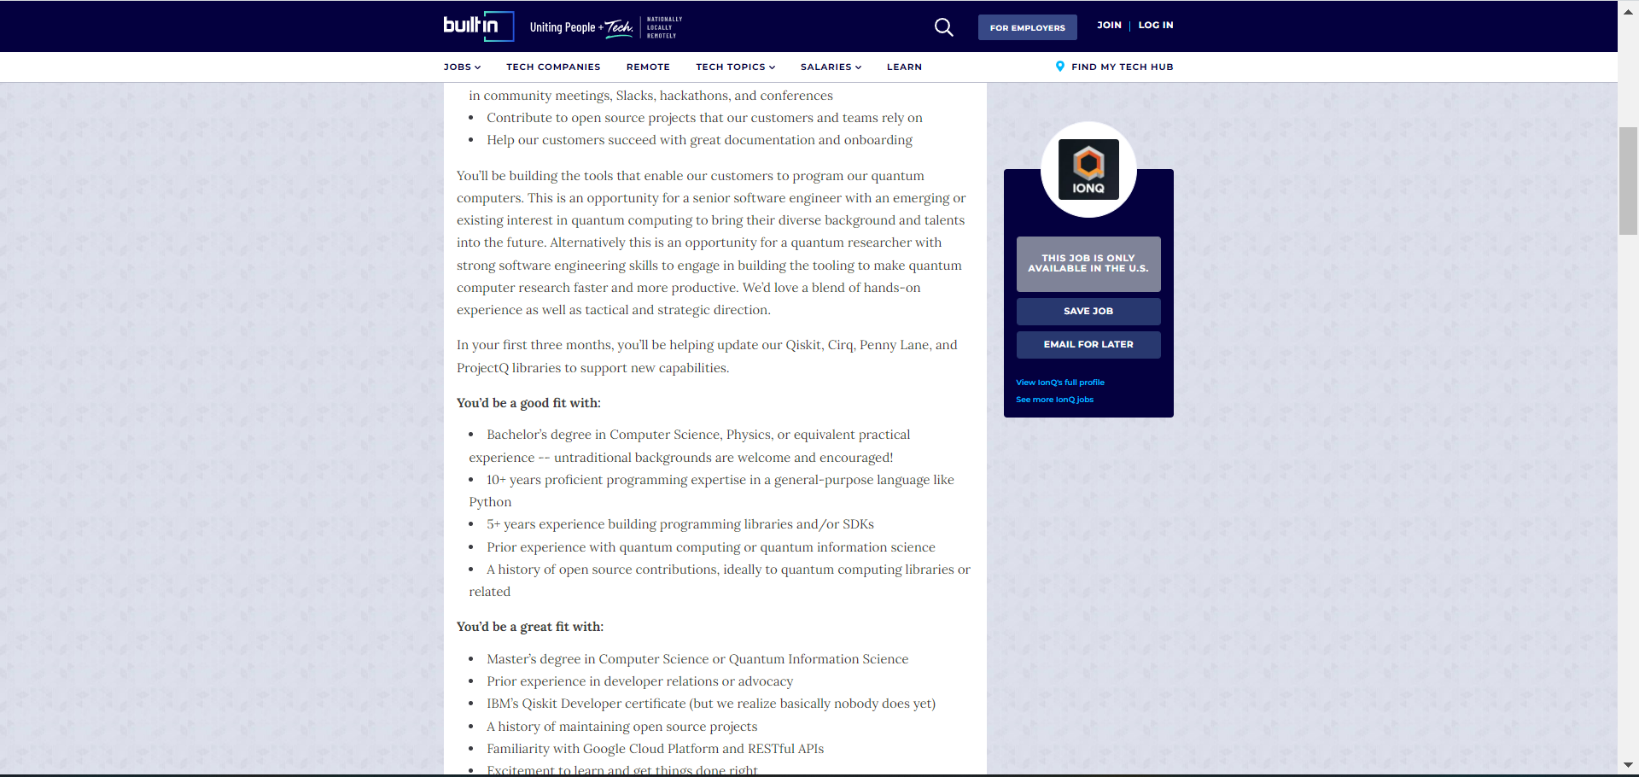

https://quantumcomputingreport.com/jobs/jobs-u-s-canada/ 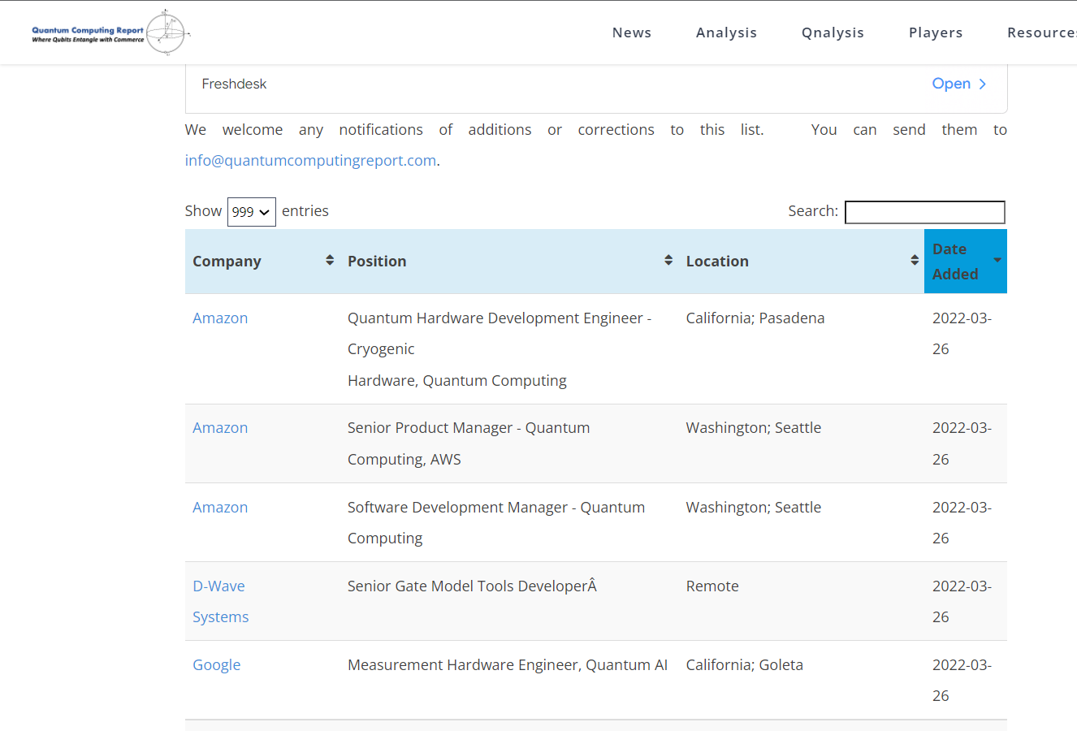

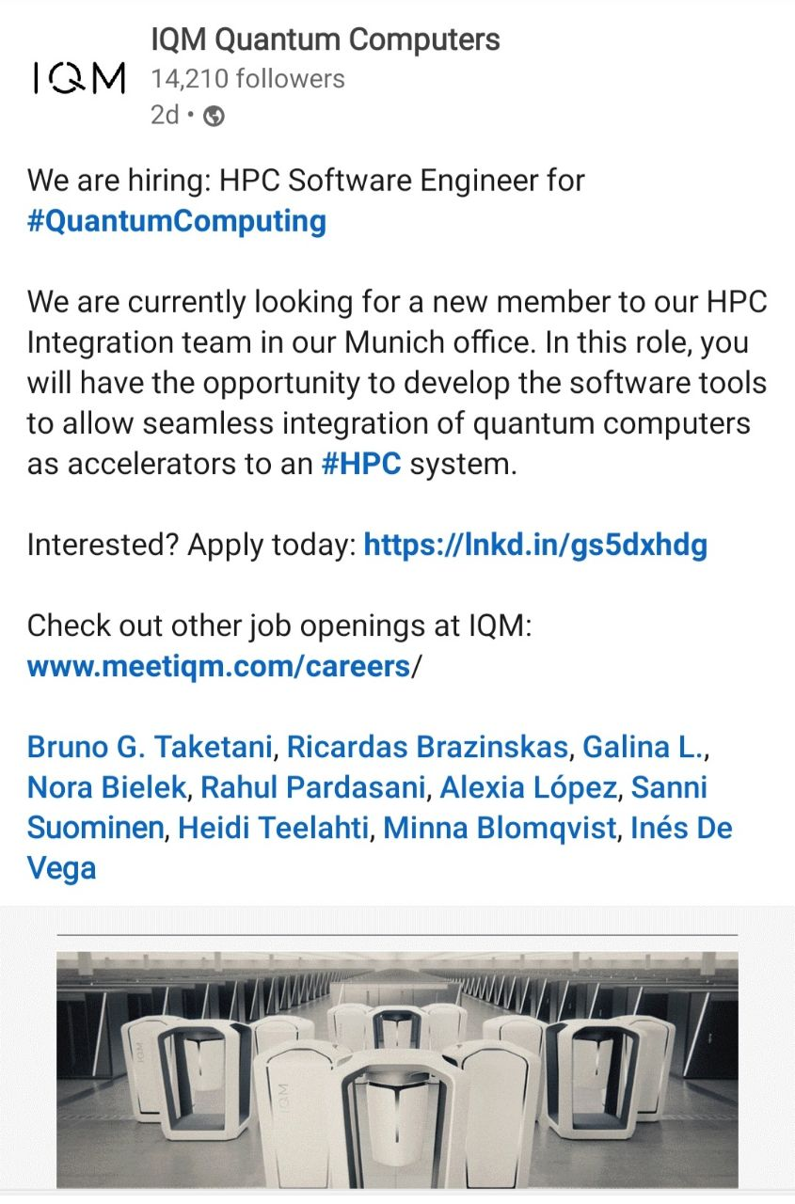

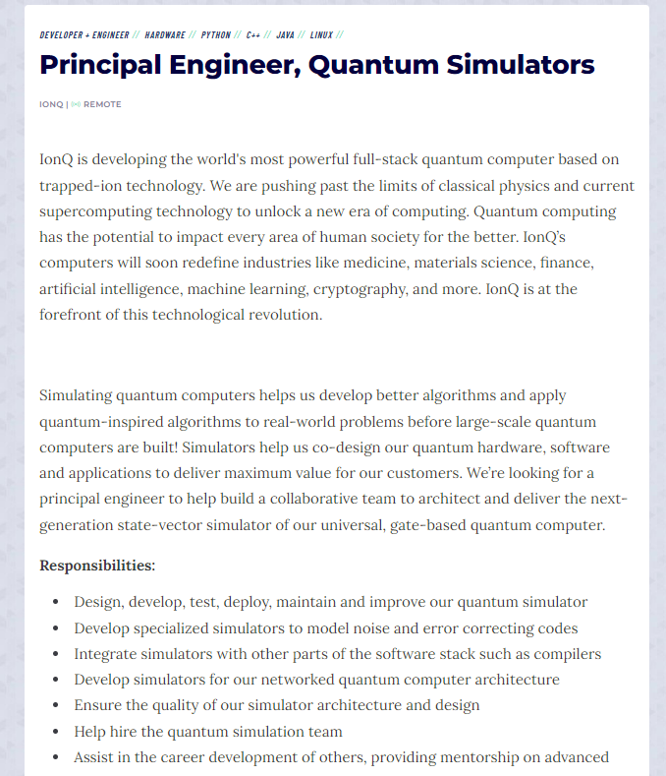

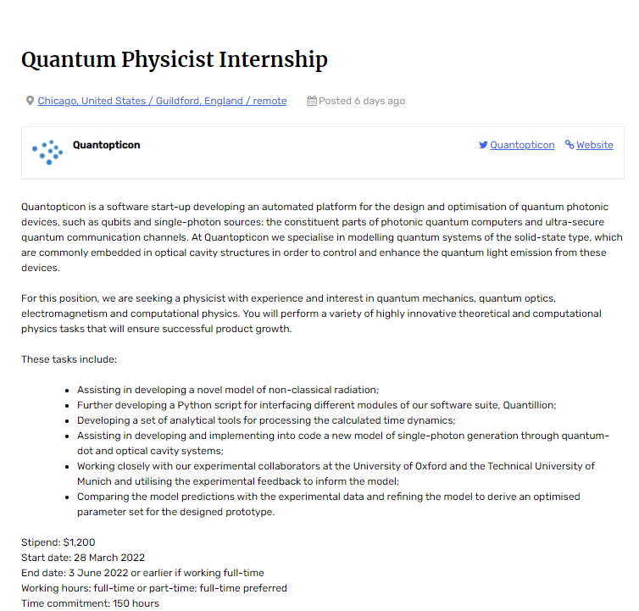

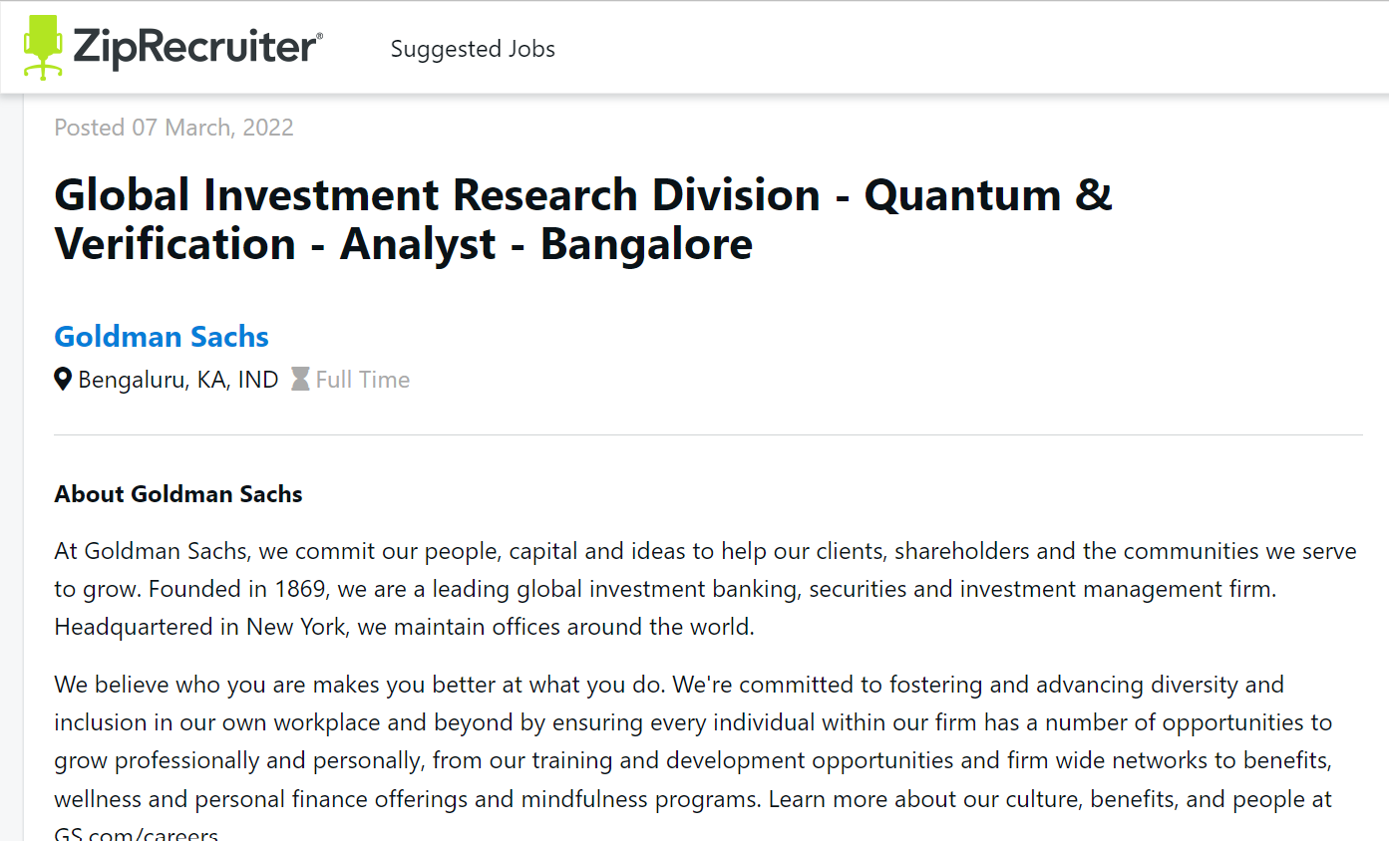

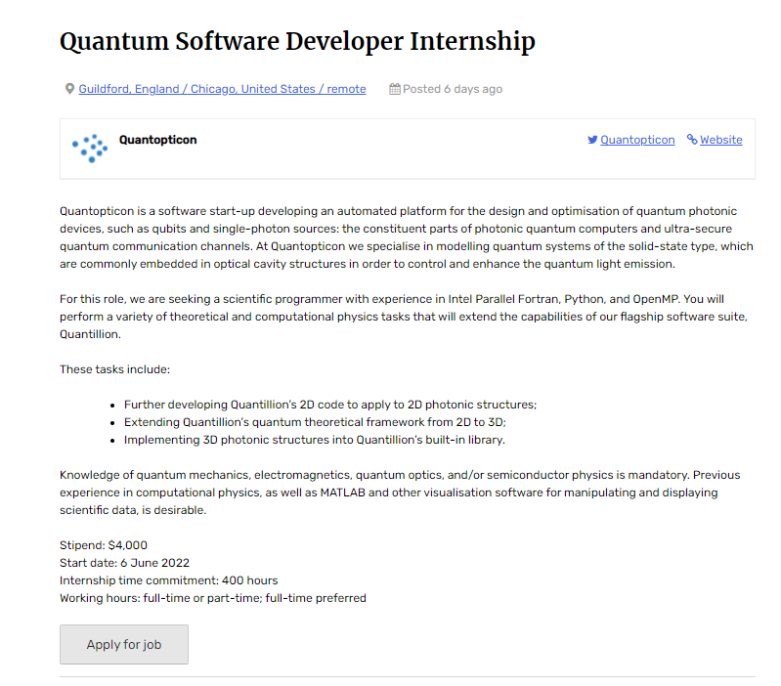

<https://quantumzeitgeist.com/job/quantopticon-guildford-england-chicago-united-states-remote-quantum-software-developer-internship/>

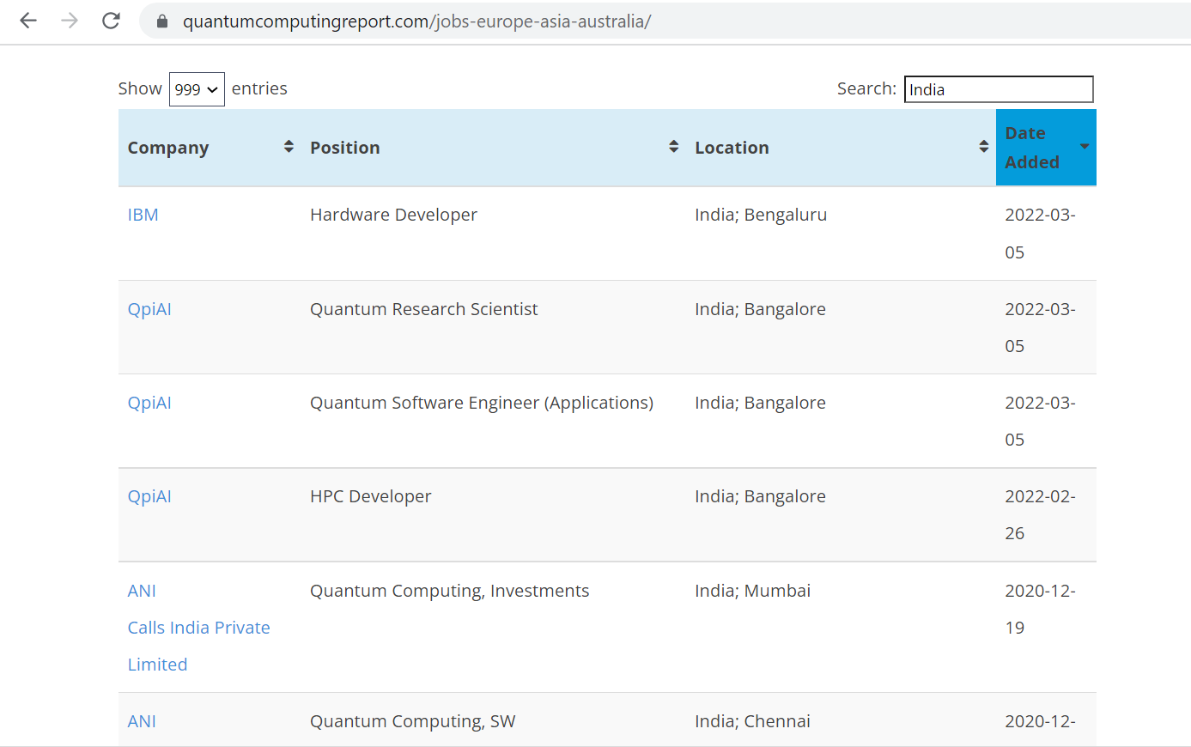

<https://quantumcomputingreport.com/jobs-europe-asia-australia/>

Course Expenditure

### MIT xPro [Quantum Computing Fundamentals](https://learn-xpro.mit.edu/quantum-computing)

### 

### Cost Expenditure:

### 

### Course Syllabus / Outcome

### 2. UChicago - [Introduction to Quantum Computing for Everyone 2](https://www.edx.org/course/introduction-to-quantum-computing-for-everyone-2)

### Expenditure:

### 

3. Delft: [Quantum 101: Quantum Computing & Quantum Internet](https://www.edx.org/professional-certificate/delftx-quantum-computing-and-quantum-internet)

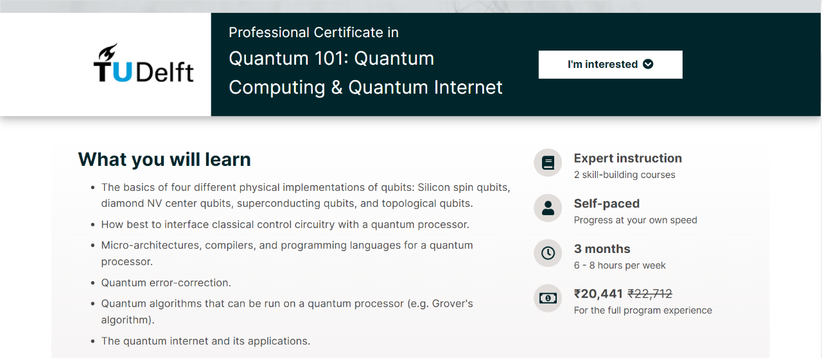 ​​

4. Delft: [The Quantum Internet and Quantum Computers: How Will They Change the World?](https://www.edx.org/course/the-quantum-internet-and-quantum-computers-how-w-2)

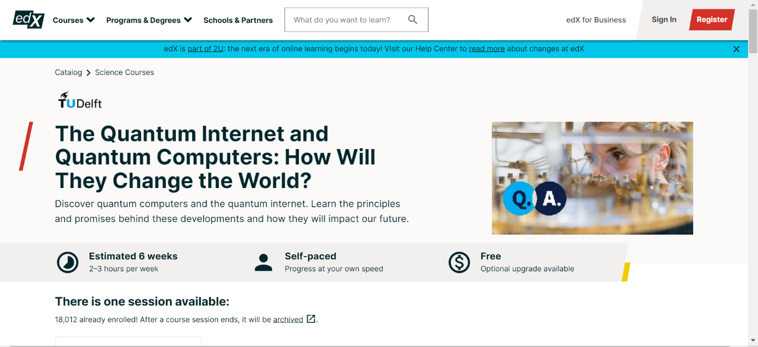

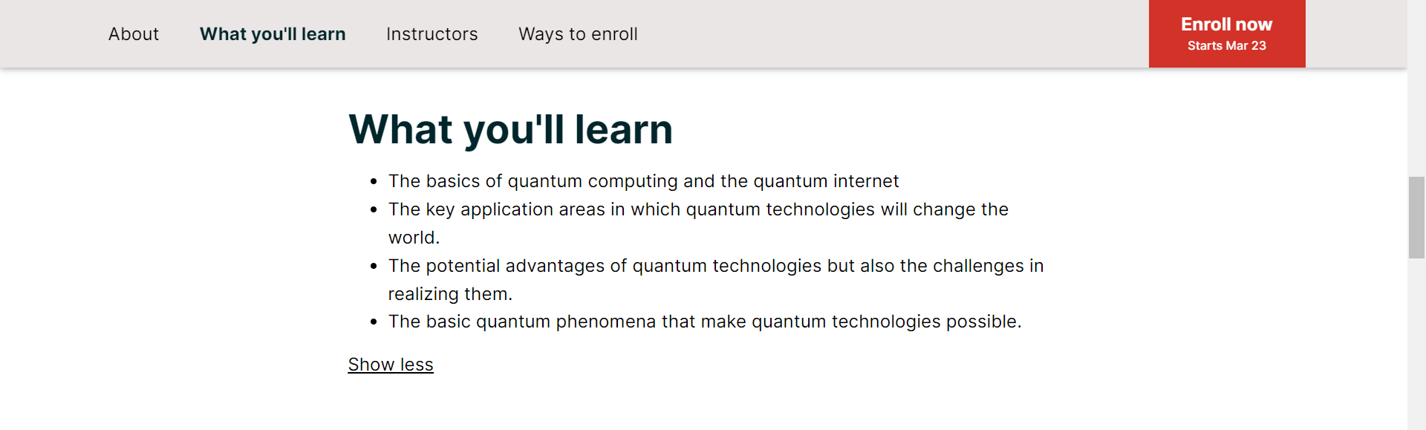

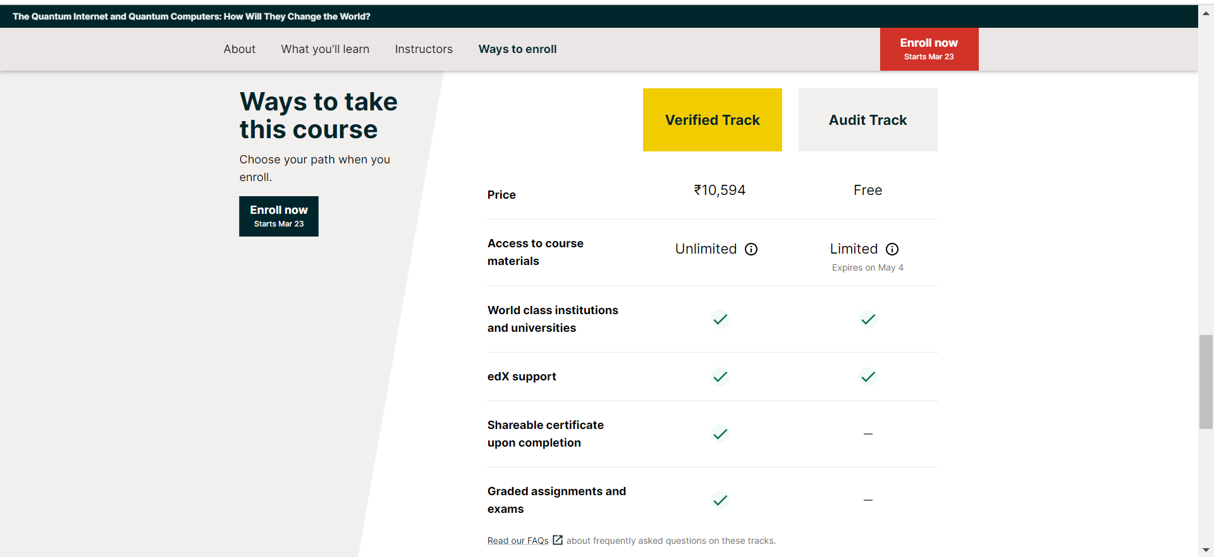

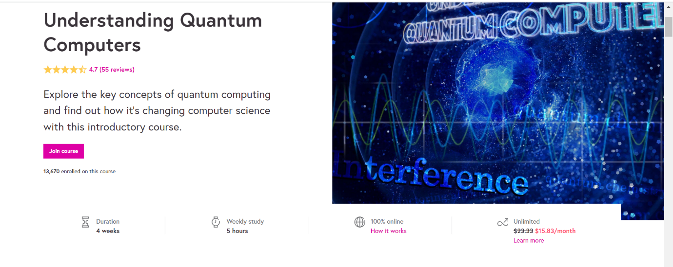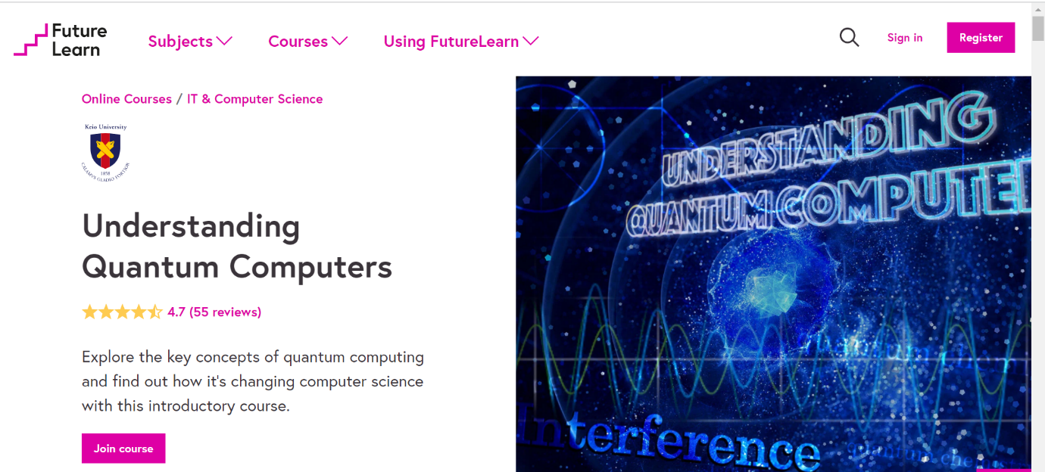5. Future Learn: [Understanding Quantum Computing](https://www.futurelearn.com/courses/intro-to-quantum-computing)

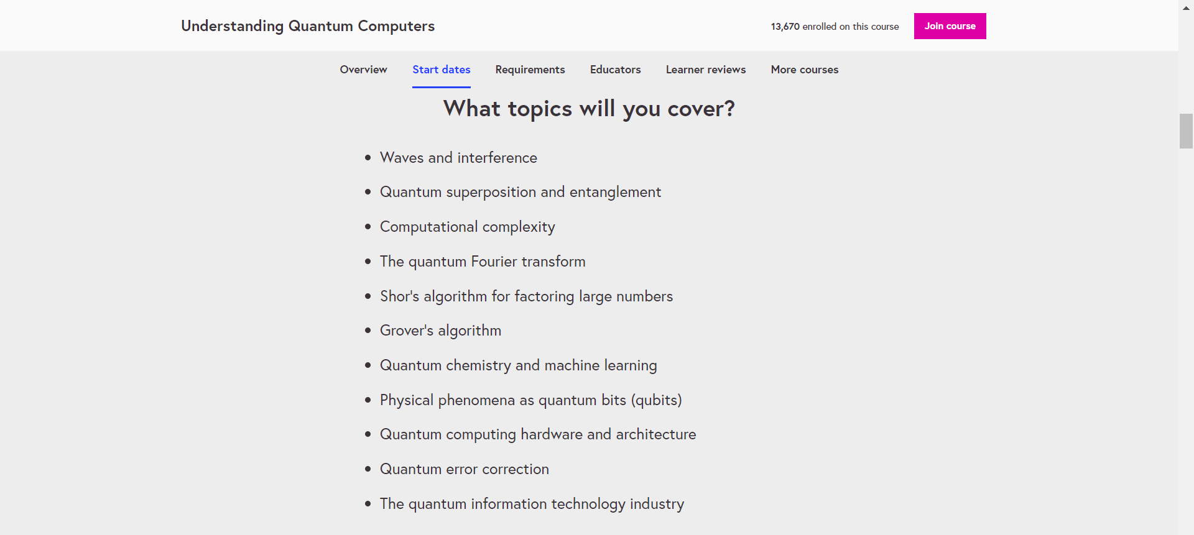

1. . Perdue: [Quantum Technology: Computing Micromasters](https://www.edx.org/micromasters/purduex-quantum-technology-computing)

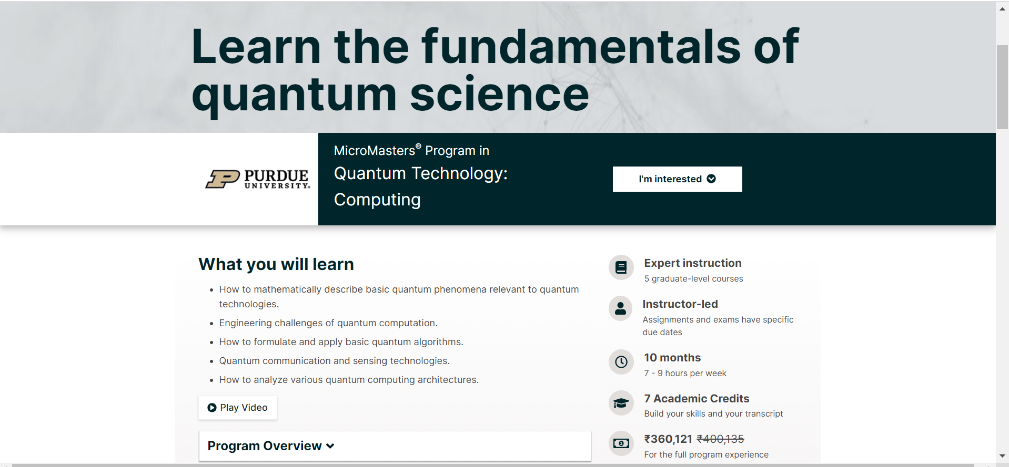

7. Qureca: [Quantum Algorithms for Computational Finance](https://platform.qureca.com/courses/quantum-algorithms-for-computational-finance/)

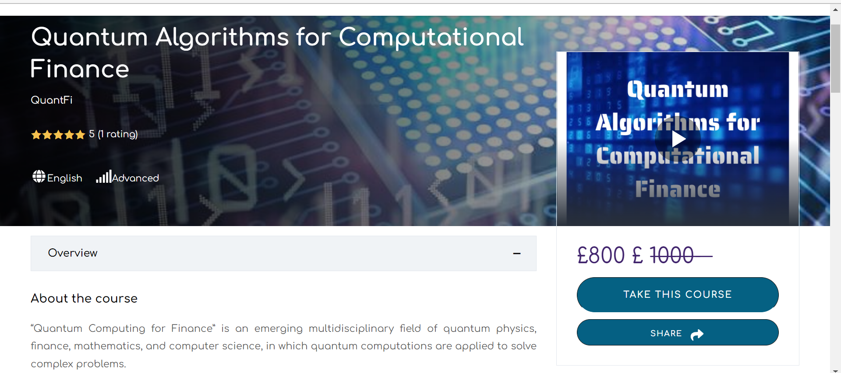

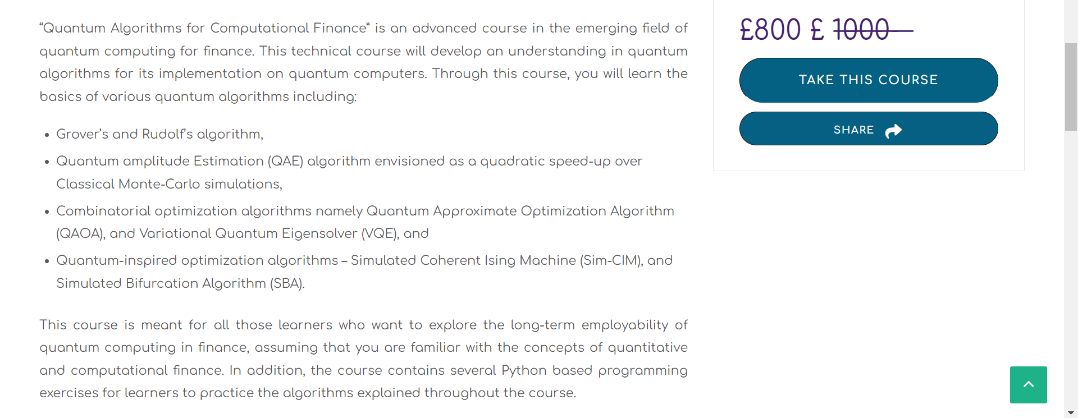

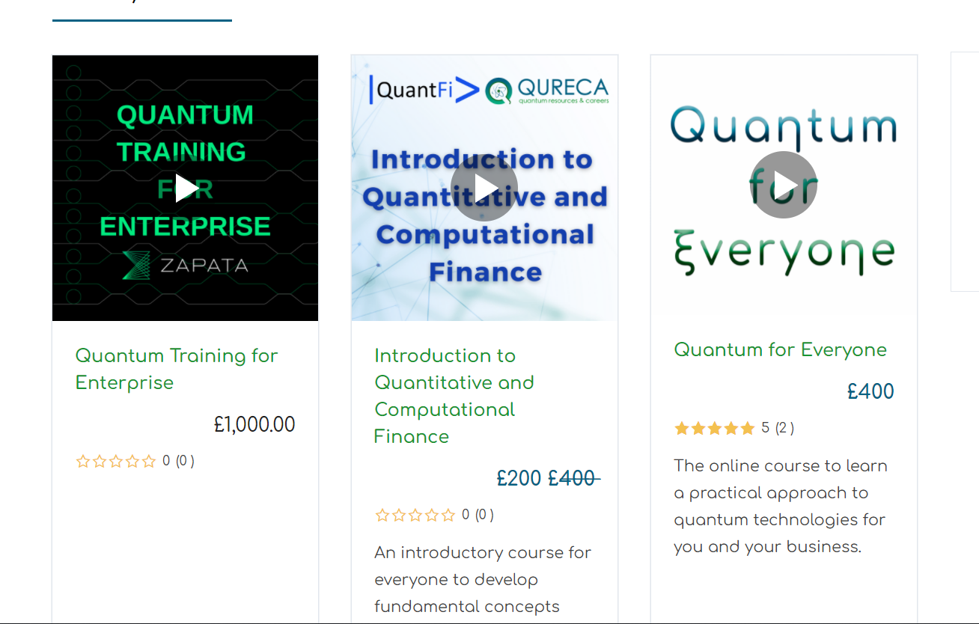

From the above details, you can observe the Cost estimation to learn Quantum Computing offered by various institutes and online platforms.

Sooner or later, every industry will start moving towards Quantum Computing, by seeing this **Mr. Vimal Daga** sir started a mission to make India’s future-ready in “Quantum Computing” along with the **#13** community.

**Initiative to Make India Future Ready**

Mr. Vimal Daga – 2x World Record holder and my mentor, is on a mission to make Indian students future-ready on various tools and technology.

Recently I can across one of his initiative “Quantum Computing” which is going to happen soon, a Full hands-on practical session. Have a look at the course contents and do register.

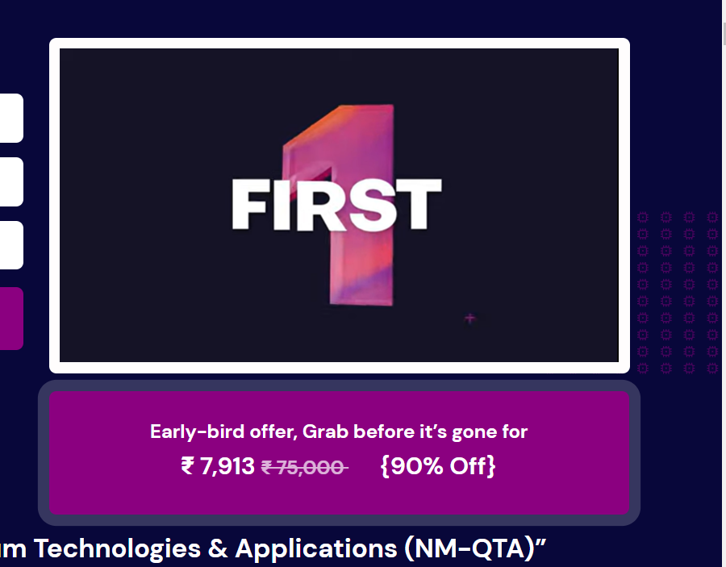

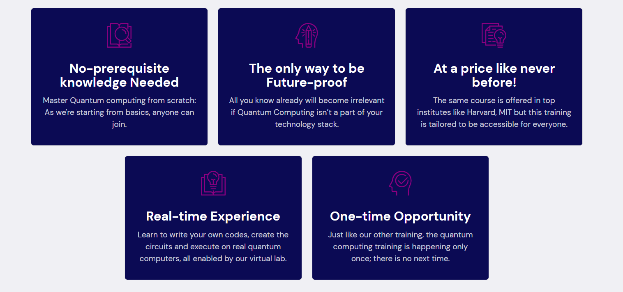

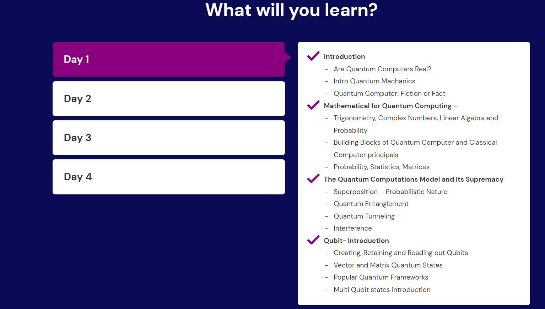

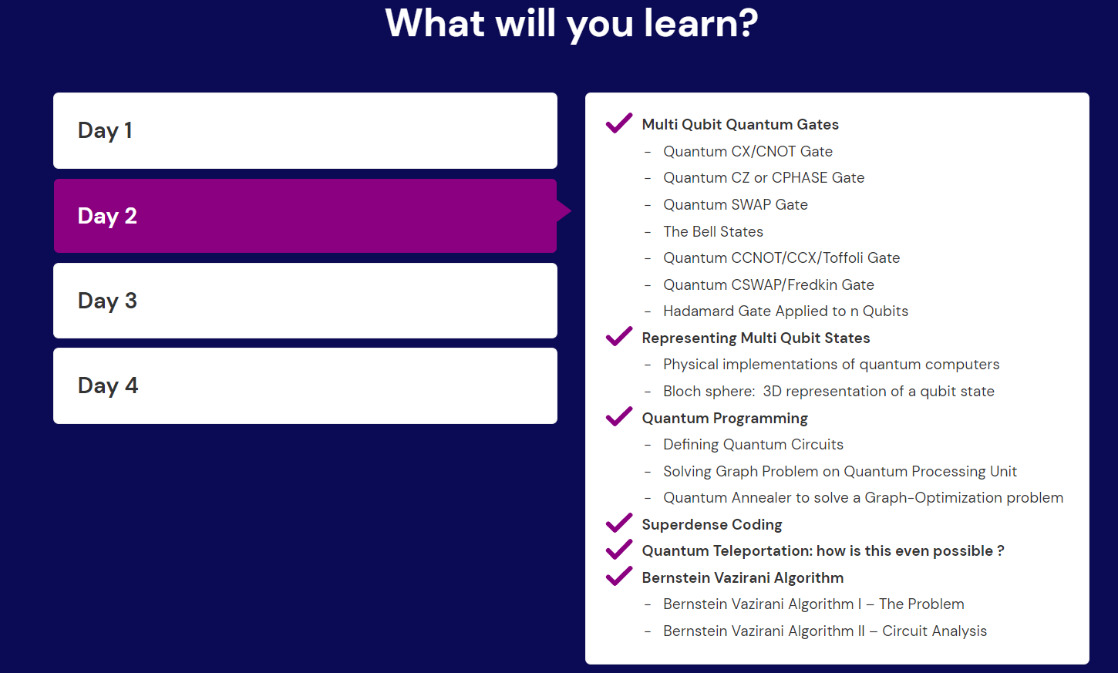

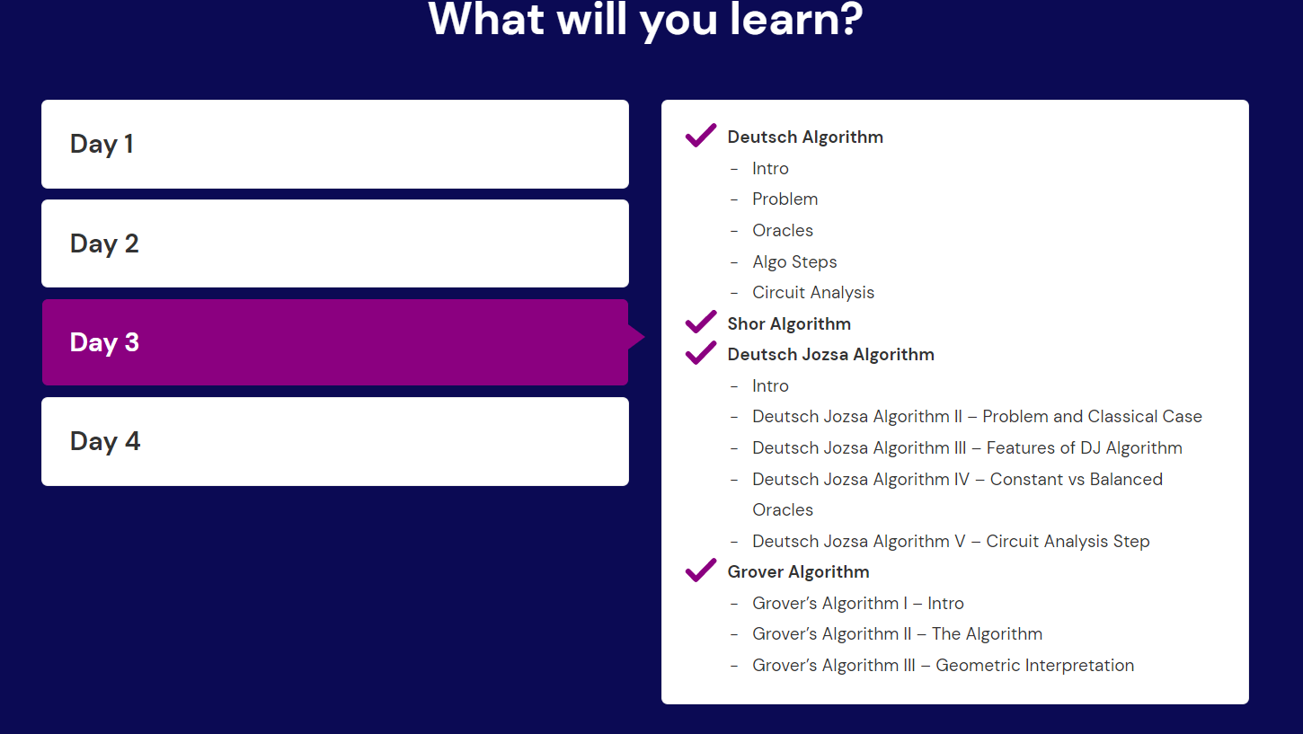

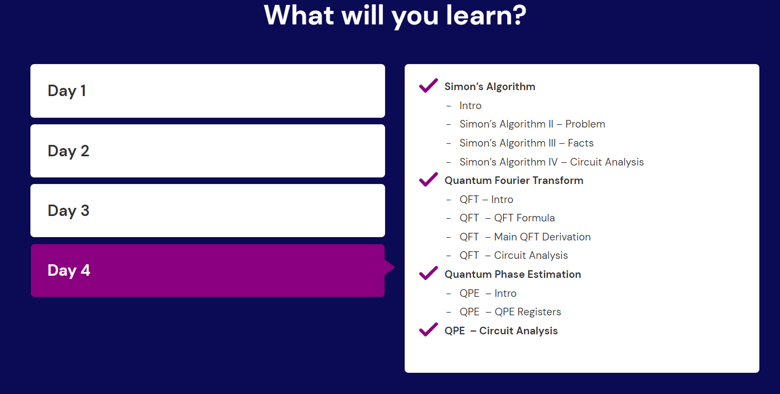

**"Sometimes the smallest step in the right direction ends up being the biggest step of your life"**

**Join Quantum revolution from #hash13 Community**

**Become India’s first-ever Quantum Computing Experts**

* **Qubits squad**

Reference:

1. <https://qureca.com/overview-on-quantum-initiatives-worldwide-update-2022/>
2. <https://www.tbsnews.net/tech/future-quantum-computing-334501>
3. <https://epjquantumtechnology.springeropen.com/articles/10.1140/epjqt/s40507-021-00114-x>
4. <https://medium.com/qiskit/the-hitchhiking-cats-guide-to-getting-a-job-in-quantum-computing-da7e3bb9ff64>
5. [Who is responsible for the quantum leap? | by Daniel Shaposhnikov | Phystech Ventures | Medium](https://medium.com/phystechventures/who-is-responsible-for-the-quantum-leap-478882ba4630)
6. <https://www.tbsnews.net/tech/future-quantum-computing-334501>
7. <https://research.aimultiple.com/quantum-computing-stats/>
8. <https://quantumcomputingreport.com/news/>
9. <https://www.mckinsey.com/business-functions/mckinsey-digital/our-insights/quantum-computing-use-cases-are-getting-real-what-you-need-to-know>
10. <https://www.ziprecruiter.in/jobs/search?q=Quantum+&l=Bengaluru%2C+India&lat=12.9634&long=77.5855&d=>

1. <https://www.ziprecruiter.in/jobs/112941700-global-investment-research-division-quantum-verification-analyst-bangalore-at-goldman-sachs?mid=%7Bsource_board.id%7D&cid=d49254a0-8f78-4422-a240-c56c13292a16&lvk=uGf2P8WXxLJzXA98a9vAlQ.--MOlwElgrJ&tsid=152014736>
2. <https://leapdroid.com/best-quantum-computing-apps-of-2021-android/>
3. <https://blog.foreignadmits.com/masters-in-quantum-computing/>
4. <https://medium.com/qiskit/the-hitchhiking-cats-guide-to-getting-a-job-in-quantum-computing-da7e3bb9ff64>
5. <https://chrome.google.com/webstore/detail/xtreme-download-manager/dkckaoghoiffdbomfbbodbbgmhjblecj/related?hl=en>
6. <https://towardsdatascience.com/quantum-computing-is-different-2178fba922cd>
7. <https://medium.com/@quantum_wa/quantum-computation-playing-the-quantum-symphony-7492fd4264c4> (For Software )
8. <https://medium.datadriveninvestor.com/quantum-computing-73-companies-that-are-changing-the-computing-landscape-f39ebf0ccfee>
9. <https://medium.com/predict/what-can-a-quantum-computer-do-that-a-classical-cannot-8b462519dcf4>
10. <https://www.mckinsey.com/featured-insights/the-rise-of-quantum-computing?cid=other-eml-onp-mip-mck&hlkid=f3270fe90faf43e393286a8b32d201b8&hctky=13445206&hdpid=71e18b49-4020-4d72-b6f5-b5453f7105e0>
11. <https://www.quantum.gov/>
12. https://research.aimultiple.com/quantum-computing-companies/
13. [PUBLICATION LIBRARY - National Quantum Initiative](https://www.quantum.gov/publications-and-resources/publication-library/)
14. [Quantum Algorithms for Computational Finance - Qureca](https://platform.qureca.com/courses/quantum-algorithms-for-computational-finance/)
15. <https://medium.com/uvc-partners-news/the-european-quantum-computing-startup-landscape-a115ffe84ad8>
16. <https://amitray.com/7-core-qubit-technologies-for-quantum-computing/>
17. [Quantum Algorithms for Computational Finance - Qureca](https://platform.qureca.com/courses/quantum-algorithms-for-computational-finance/)
18. <https://www.quantum.gov/publications-and-resources/publication-library/>
19. <https://www.mckinsey.com/featured-insights/the-rise-of-quantum-computing>

